# Implement read operation

Fetch(EBELN, BUKRS, BSTYP, BSART, ERNAM, LIFNR, EKORG, EKGRP, KUNNR, ADRNR) from EKKO for given EBELN.

### ABAP Development

**Go to Tcode Se11 and create bespoke Structure ZTRAINSTRUCT_EKKO**

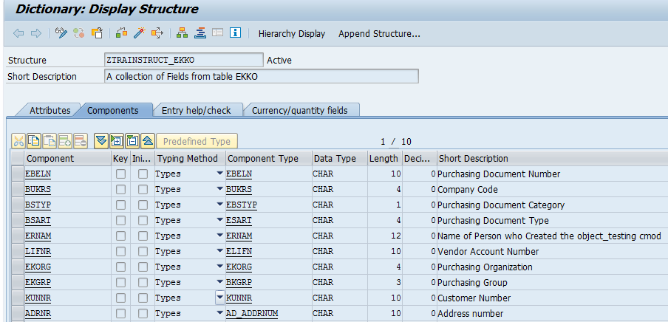

**Go to Tcode SE37 and Create bespoke RFC ZTRAINRFC**

FUNCTION ztrainrfc.  
*"----------------------------------------------------------------------  
*"*"Local Interface:  
*"  IMPORTING  
*"     VALUE(IV_EBELN) TYPE  EBELN  
*"  EXPORTING  
*"     VALUE(WA_HEADER) TYPE  ZTRAINSTRUCT_EKKO  
*"  TABLES  
*"      TT_RETURN STRUCTURE  BAPIRET2 OPTIONAL  
*"----------------------------------------------------------------------  
  DATA:ls_return TYPE bapiret2.  
*"* Fetch data from EKKO Table  
  SELECT SINGLE ebeln  
                bukrs  
                bstyp  
                bsart  
                ernam  
                lifnr  
                ekorg  
                ekgrp  
                kunnr  
                adrnr  
                FROM ekko  
                INTO wa_header  
                WHERE ebeln = iv_ebeln.  
  IF sy-subrc <> 0.  
    ls_return-type = 'E'.  
    ls_return-message = text-001.  
    REPLACE '&1' WITH iv_ebeln IN CHARACTER MODE INTO ls_return-message.  
    APPEND ls_return TO tt_return[].  
  ENDIF.  
  
ENDFUNCTION.

## Gateway Development

**Step1: Create Gateway Project**

Go to Tcode SEGW -> Click on Create button as highlighted -> furnish details->Save 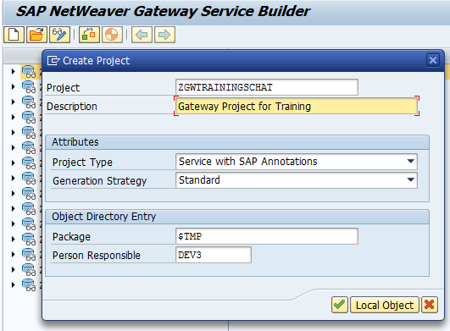

Click on .

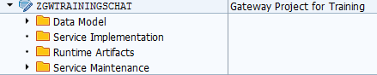



**Step2: Create Entity Type & Entity Set**

Right Click on **Data Model** tab under project **ZGWTRAININGSCHAT** -> Import-> RFC/BOR Interface

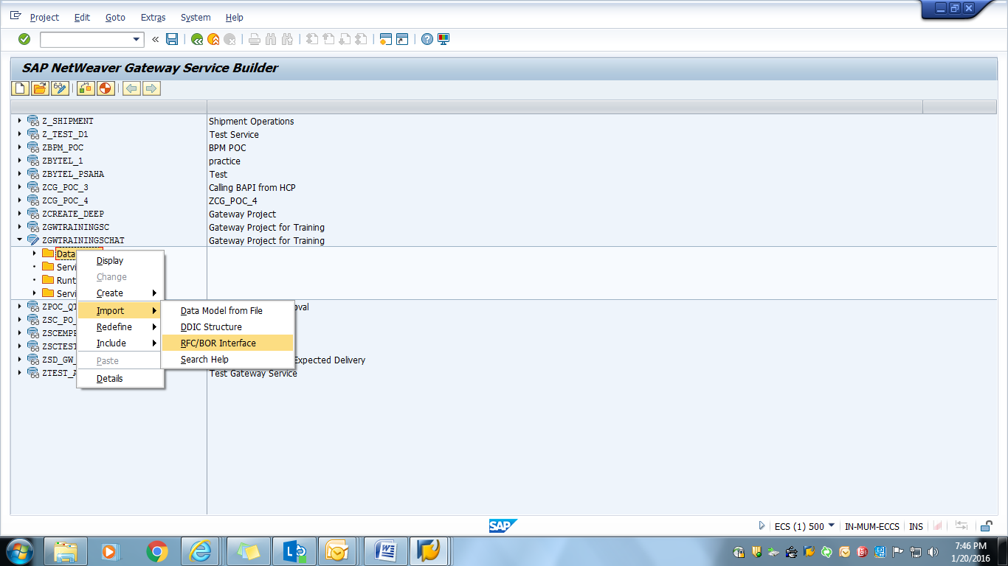

Insert **Entity Type** **Name** as ‘*ZREADOPERATION*’**,**

**Data Source Type** as ‘Remote Function Call’

**Data Source Name** as ‘*ZTRAINRFC*’

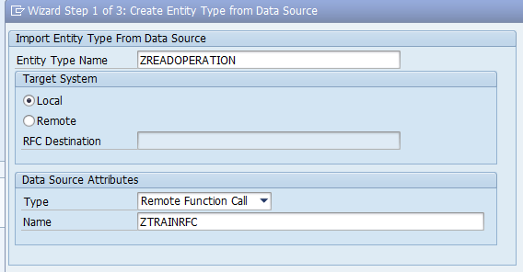

Click on ‘Next’.

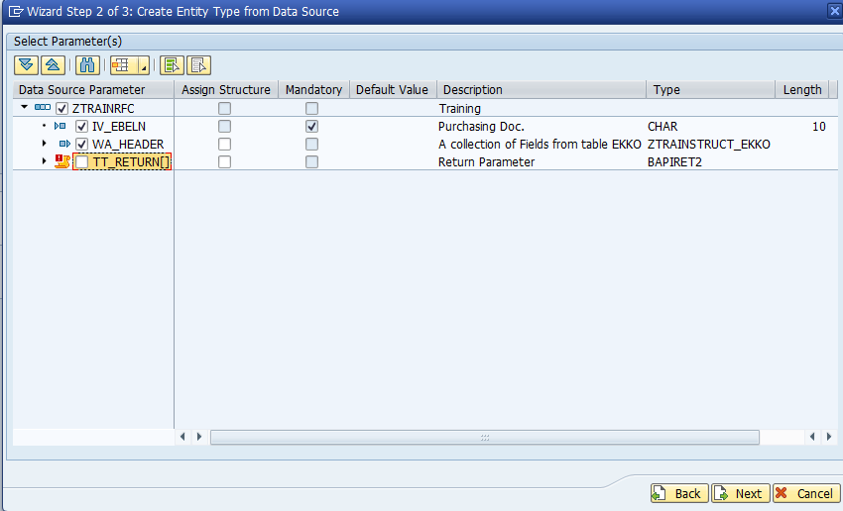

Click on ‘Next’ and Assign field as key

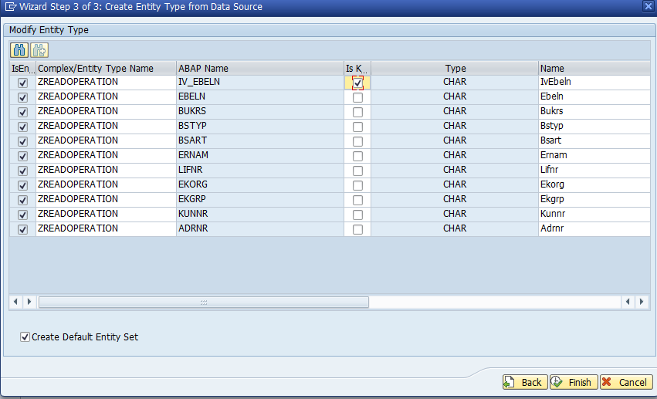

Press Finish

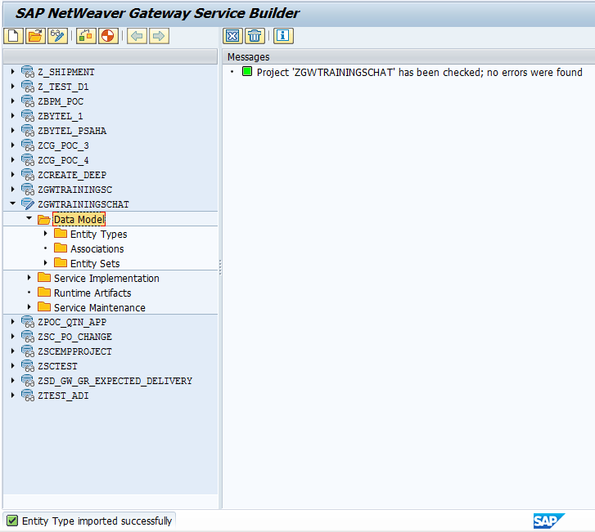

Entity type *ZREADOPERATION* and Entity Set *ZREADOPERATIONSet* created,

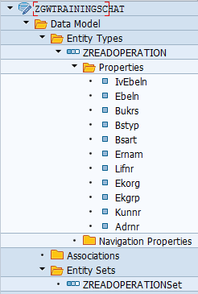

**Step3: Service Implementation**

Go to Service Implementation section and expandEntity Set *ZREADOPERATIONSet*

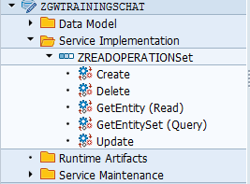

Right Click on operation *GetEntity(Read)* and click on Map to Data Source

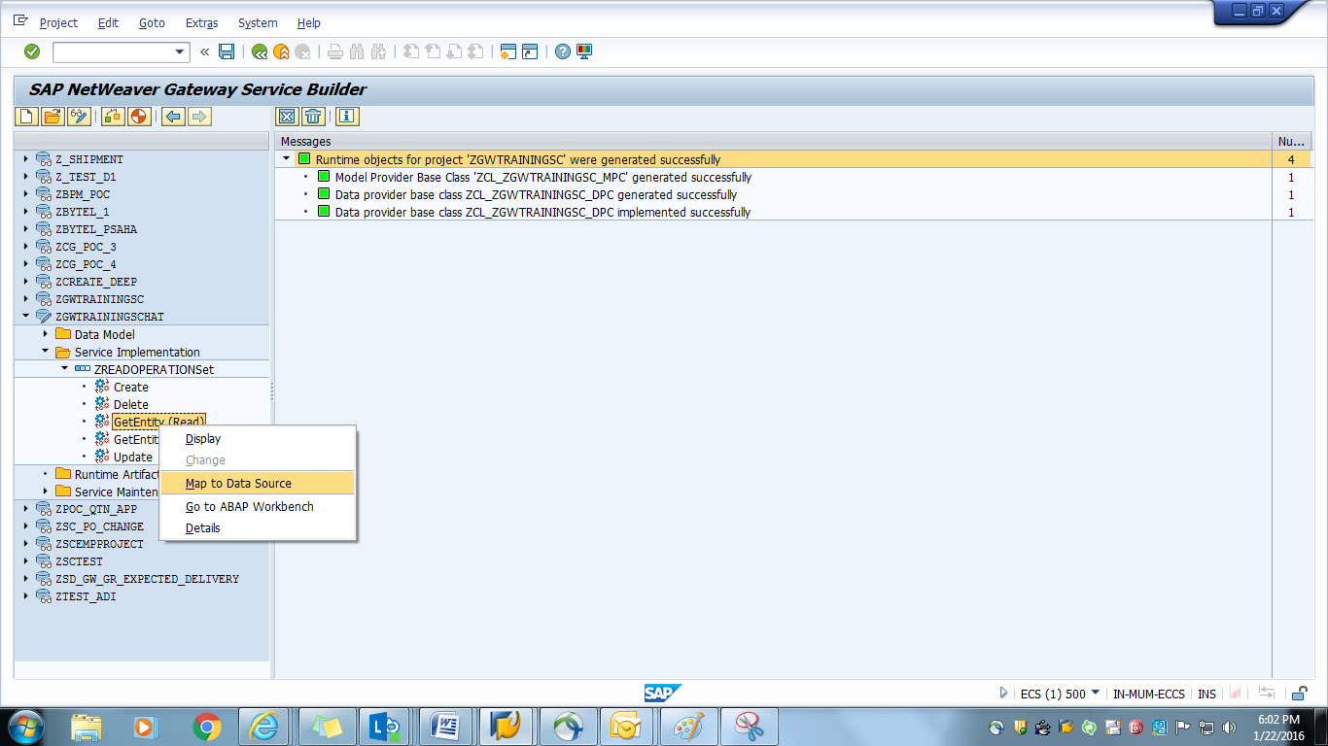

Insert Type as ‘Remote Function Call’ and Press 

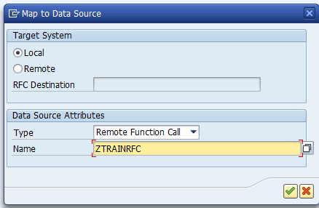

Click on Propose Mapping Tab or Drag & Drop fields from Data Source Parameter panel at right hand 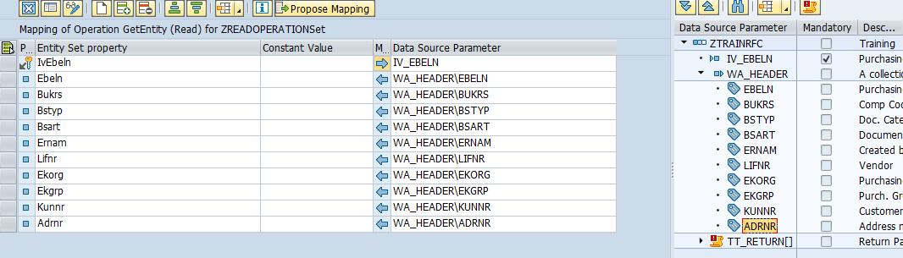

**Step4: Generate Runtime Artifacts**

Select Project and click on 

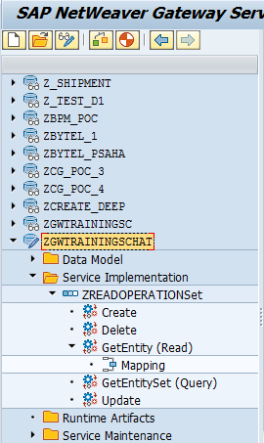

Model Provider Class,Data Provider Class,Technical Service Name generated.Press 

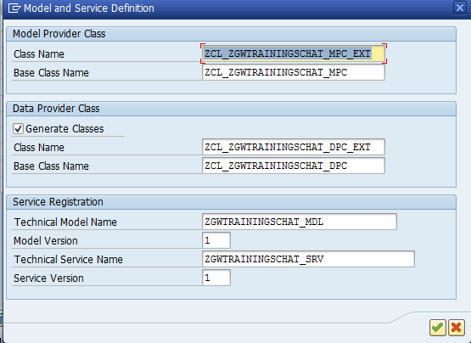

Run time Objects generated

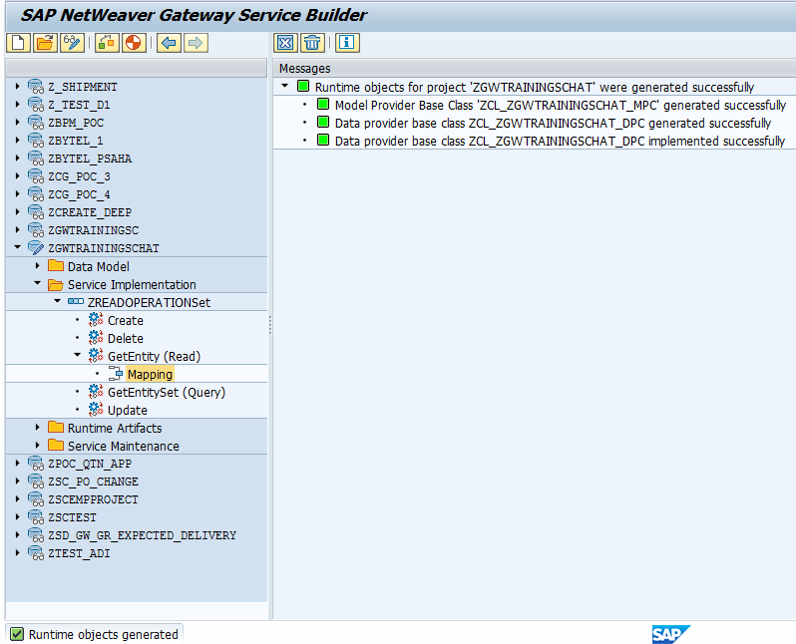

Redefine the method ZREADOPERATIONSE_GET_ENTITY of class ZCL_ZGWTRAININGSCHAT_DPC_EXT putting right click on method and select Redefine

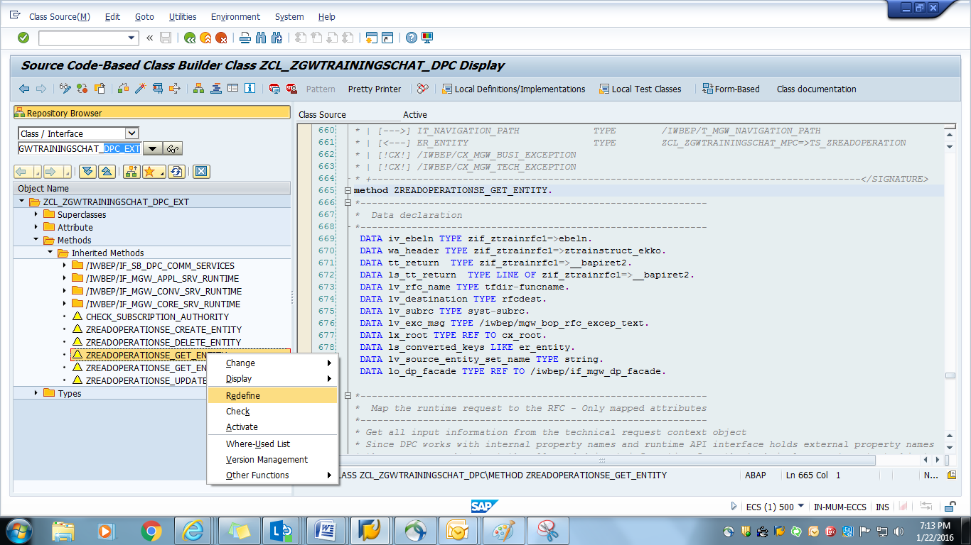

Activate the code,

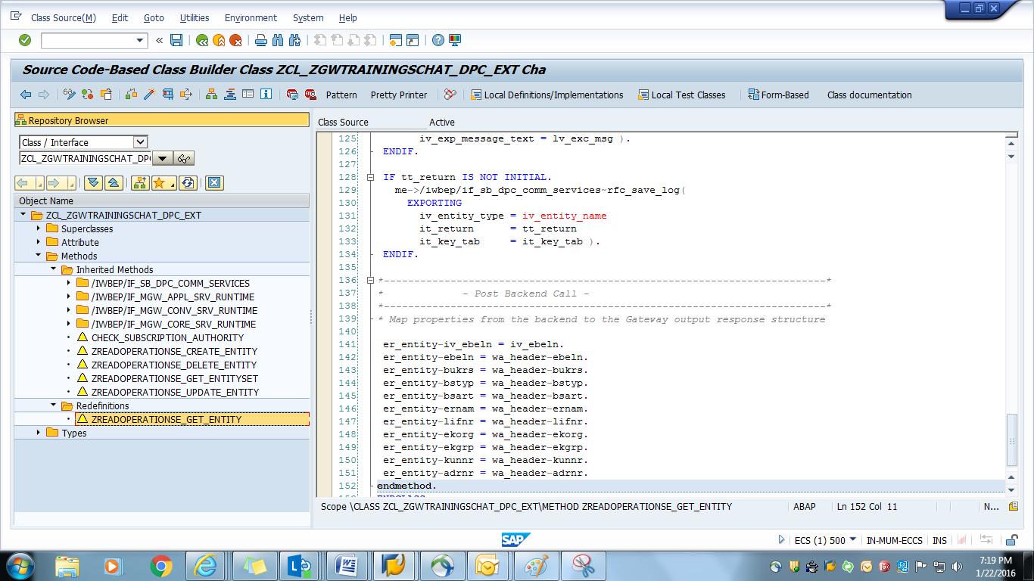

**Step5: Service Maintenance**

Go to Service Maintenance tab and select LOCAL

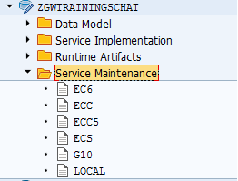

Press Register tab , insert System Alias as **local** and Press 

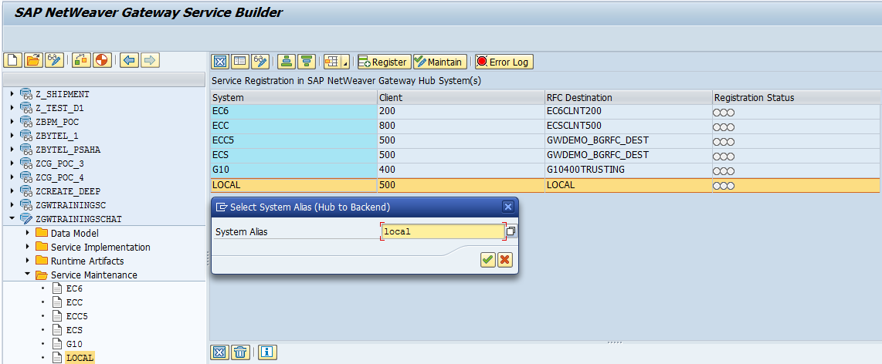

Fill Package Assignment field and Press 

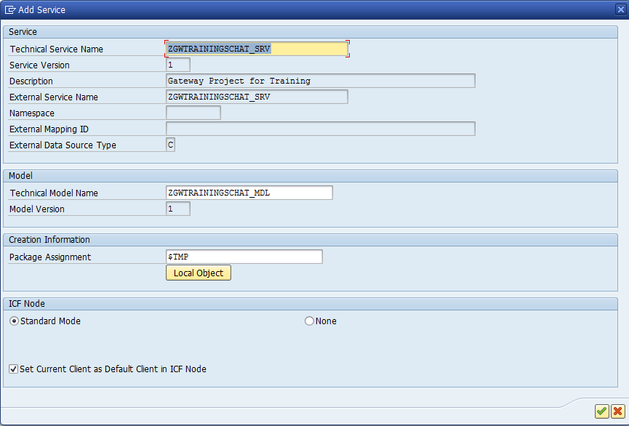

Service Maintenance done Successfully

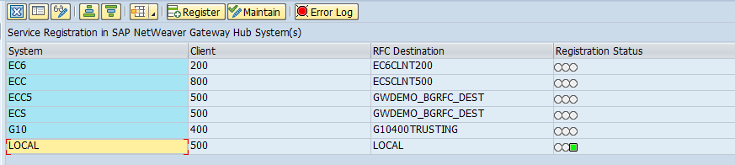

**Step6: Test Service**

Click on Maintain



Click Gateway Client

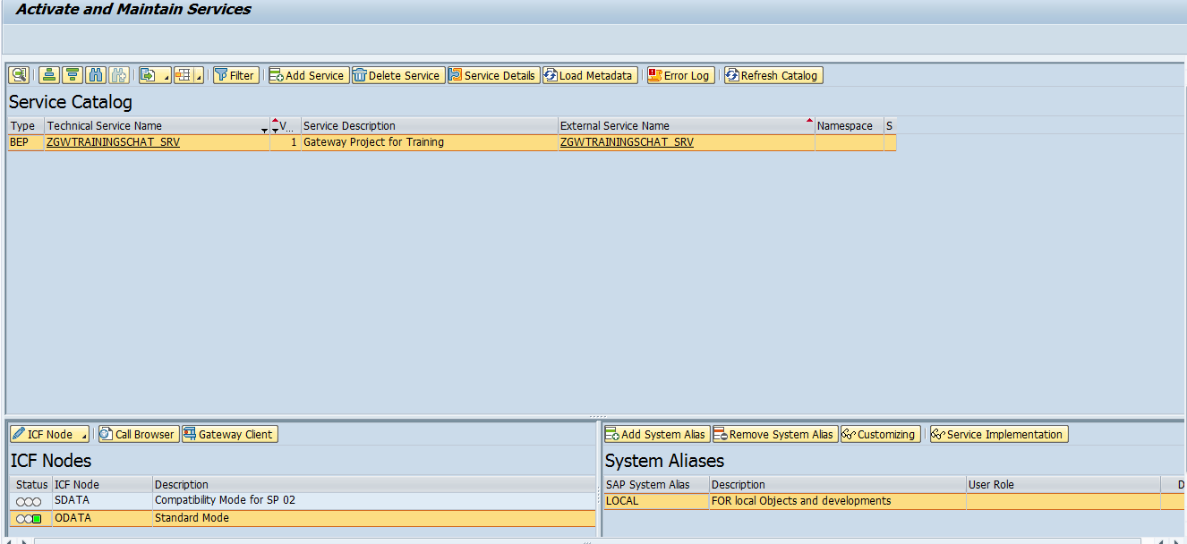

Execute the http request (with GET command) as /sap/opu/odata/sap/ZGWTRAININGSCHAT_SRV/ZREADOPERATIONSet(IvEbeln='4500000015'),

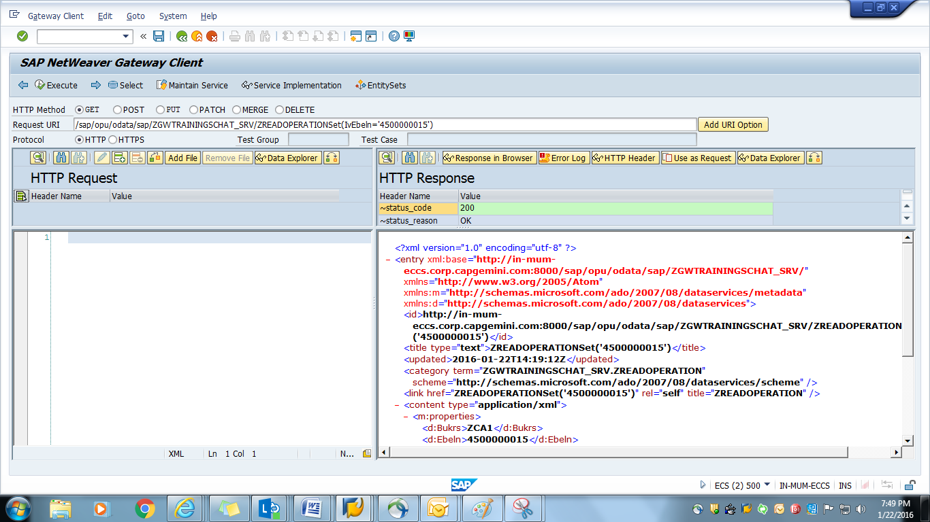

Result

